[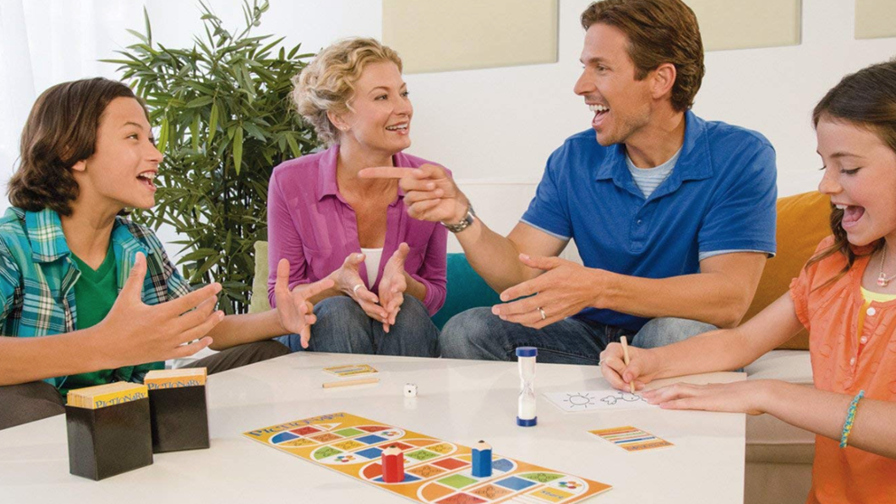](https://www.google.com/url?sa=i&url=https%3A%2F%2Fwww.lavanguardia.com%2Fcomprar%2F20181203%2F453311295042%2Fjuegos-mesa-ninos-beneficios-cognitivos-regalos-navidades.html&psig=AOvVaw1RlG5mOXweqQSOhHfymz6i&ust=1584561574676000&source=images&cd=vfe&ved=0CAIQjRxqFwoTCIDc24CmougCFQAAAAAdAAAAABAU)

[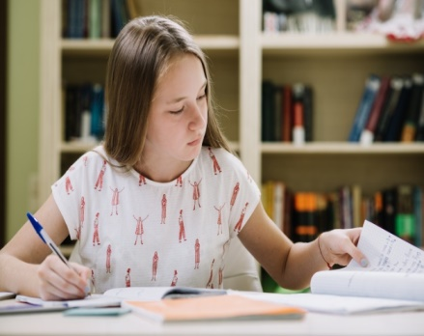](https://www.google.com/url?sa=i&url=https%3A%2F%2Fwww.freepik.es%2Ffoto-gratis%2Fnina-sentada-estudiando_1314034.htm&psig=AOvVaw0kvXqXOj0yjh-0DKsg2x5f&ust=1584561834718000&source=images&cd=vfe&ved=0CAIQjRxqFwoTCKjDyICnougCFQAAAAAdAAAAABAO) [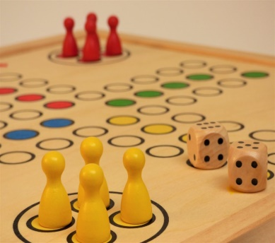](https://www.google.com/url?sa=i&url=https%3A%2F%2Fwww.redcenit.com%2Fjuegos-de-mesa-en-familia%2F&psig=AOvVaw1RlG5mOXweqQSOhHfymz6i&ust=1584561574676000&source=images&cd=vfe&ved=0CAIQjRxqFwoTCIDc24CmougCFQAAAAAdAAAAABAZ)[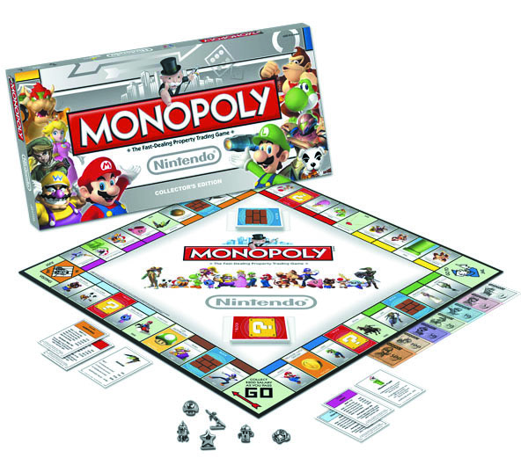](https://www.google.com/url?sa=i&url=http%3A%2F%2Fmirnasmith.weebly.com%2Fla-belleza-y-la-esteacutetica%2Farchives%2F06-2017&psig=AOvVaw1RlG5mOXweqQSOhHfymz6i&ust=1584561574676000&source=images&cd=vfe&ved=0CAIQjRxqFwoTCIDc24CmougCFQAAAAAdAAAAABA0)