These are the activities for the week of March 30th to April 3rd, remember that everything will be checked when we go back to school or upload the pictures to Google Classroom with your full name and date on the page.
Monday March 30th Student’s book page 101 and workbook page 67
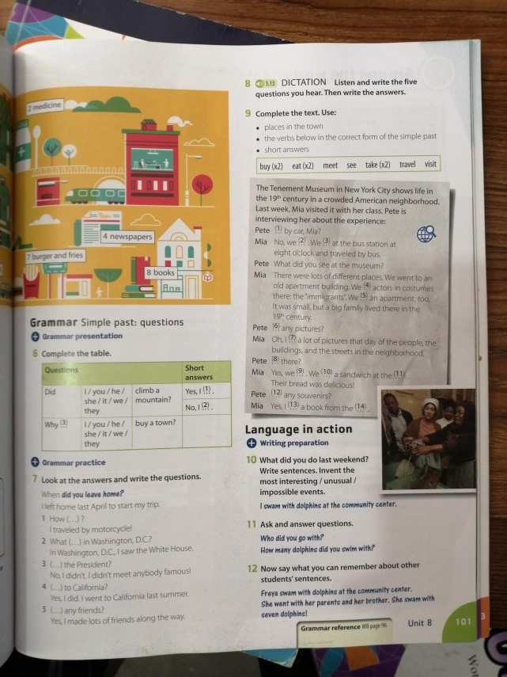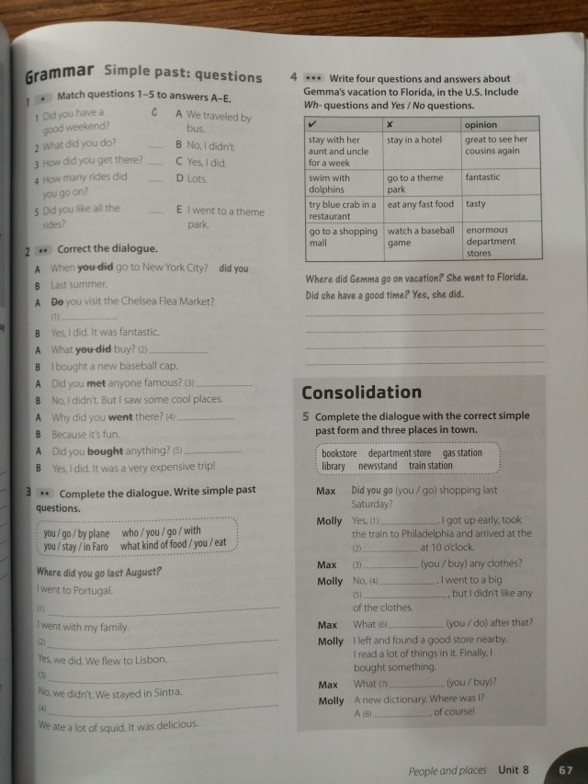
*for activity 8 from the student’s book, copy and answer these questions:
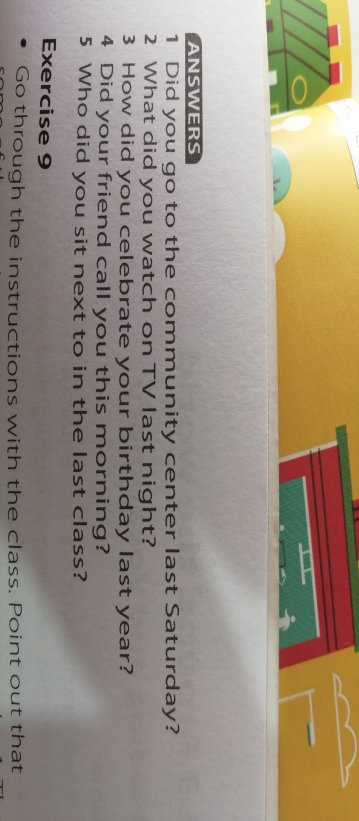
Grammar reference to help you out
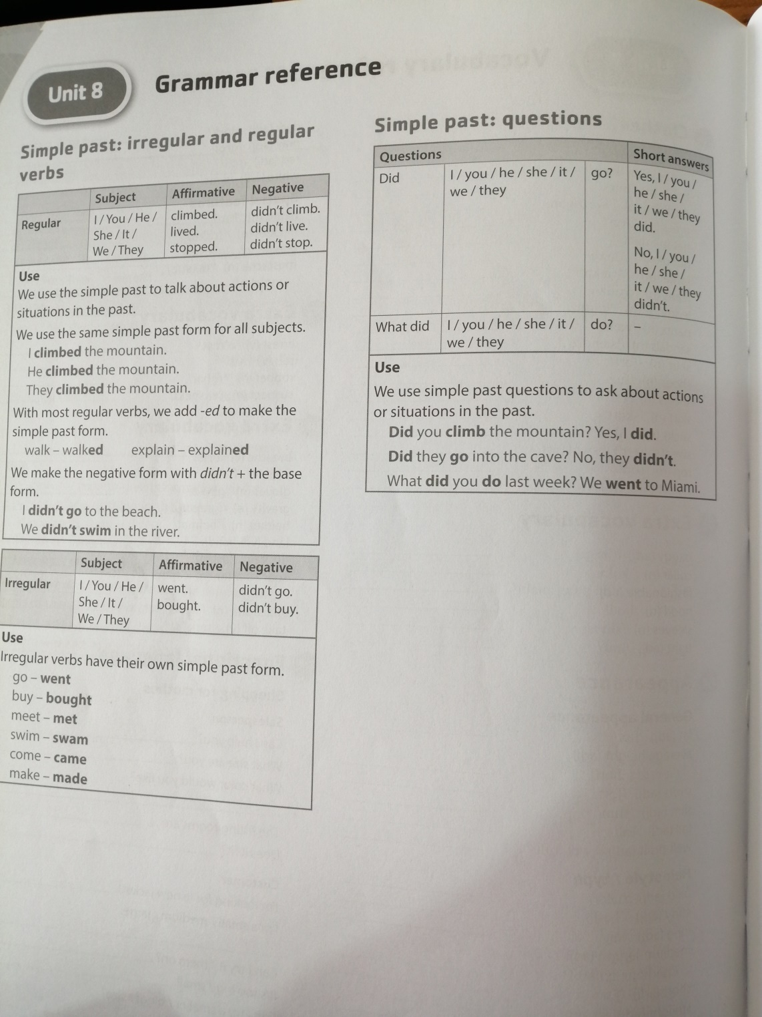

Tuesday March 31st and Thursday April 2nd
Student’s book pages 102 and 103, Workbook page 68
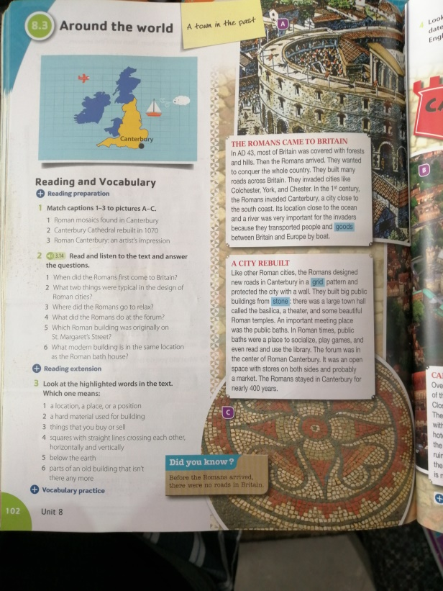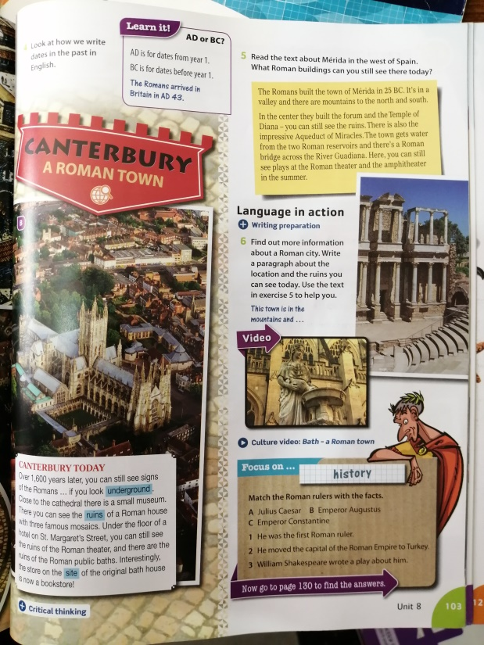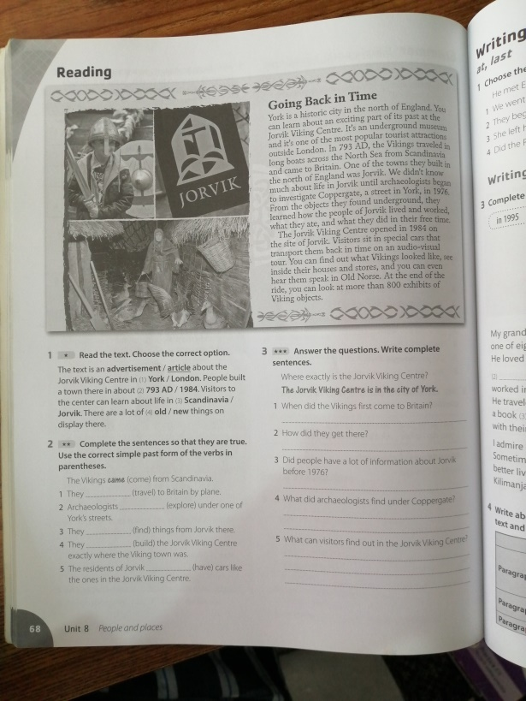

Friday April 3rd, Student’s book page 108, Workbook pages 70 and 71
*for activities 3 and 4 from the Student’s book, read the text 3.18
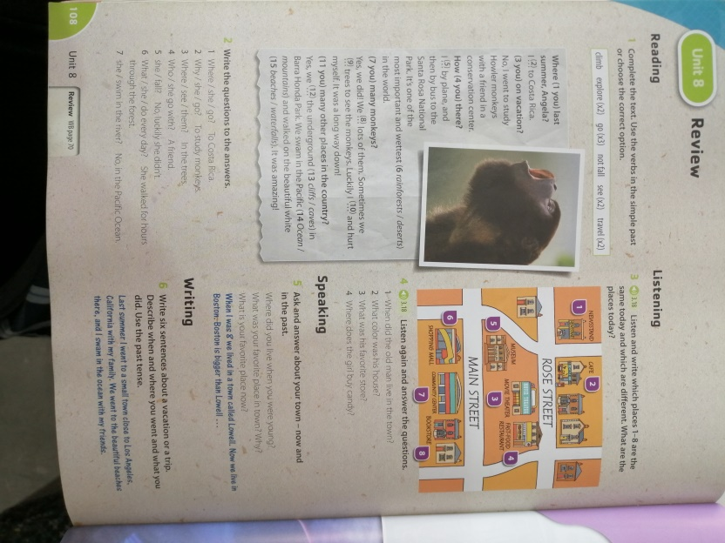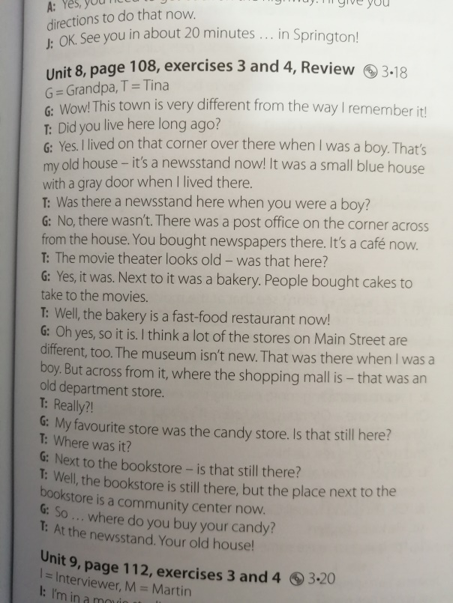
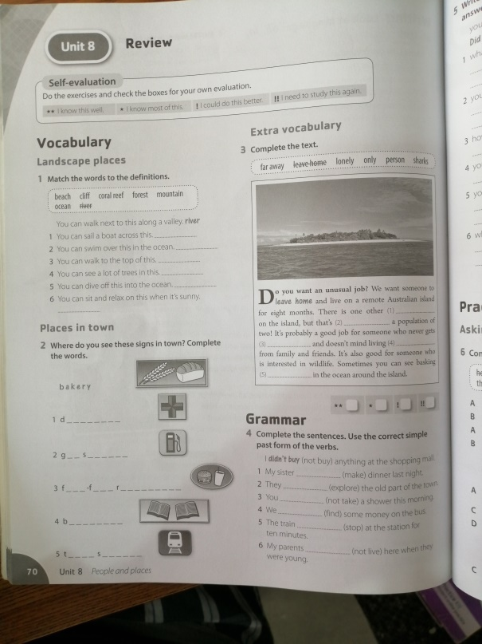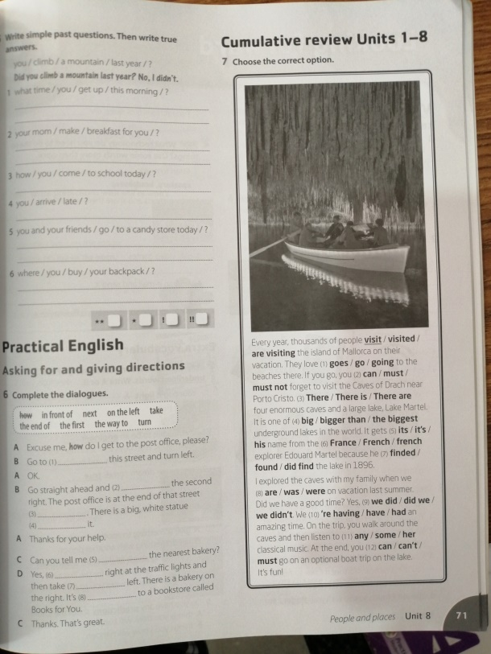
This week’s MyOn book is called “Is time travel possible?” , you have to write the book report on the 2nd section of your notebook.

