These are the activities for the week of March 30th to April 3rd, remember that everything will be checked when we go back to school or upload the pictures to Google Classroom with your full name and date on the page.
Monday March 30th Student’s book page 101 and workbook page 67
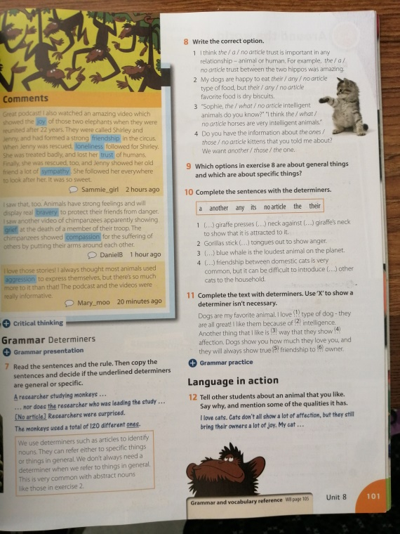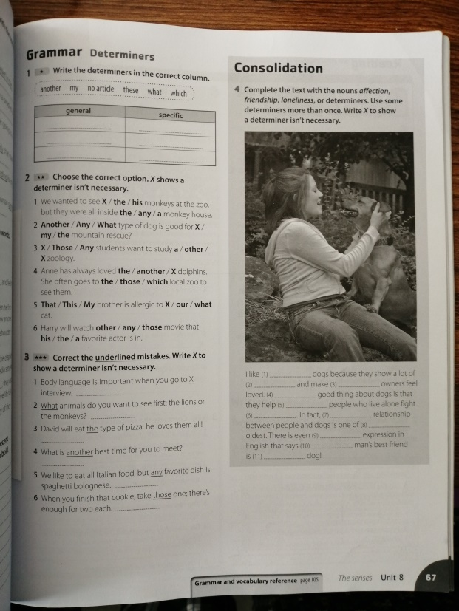
Grammar reference to help you out
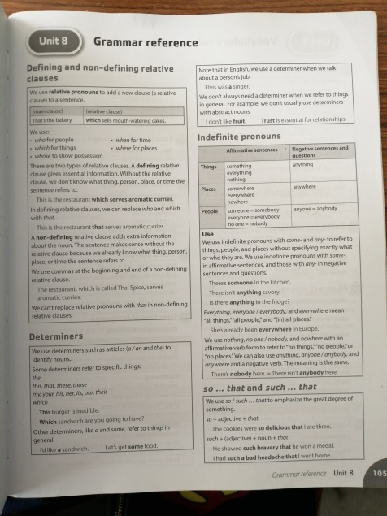
Tuesday March 31st , Thursday April 2nd
Student’s book pages 102 and 103, Workbook page 68
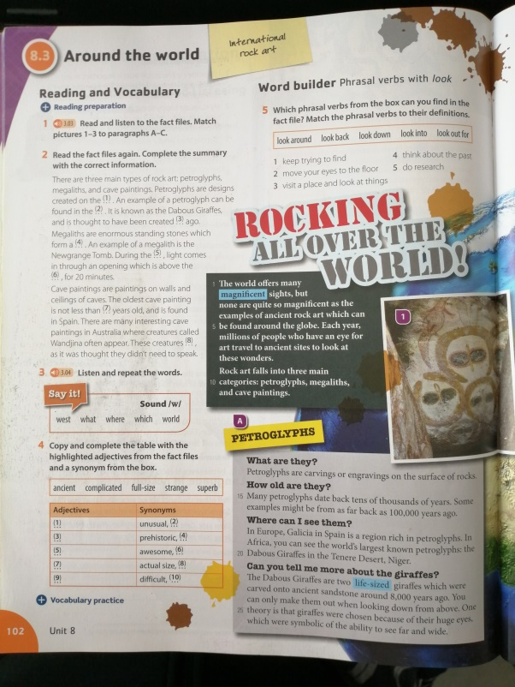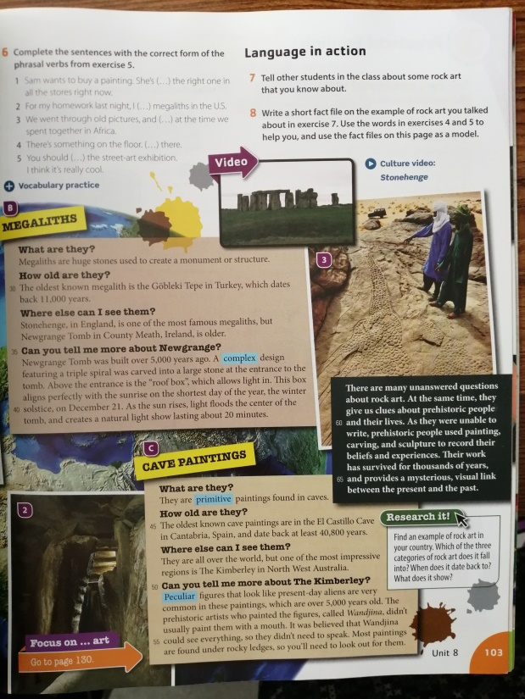
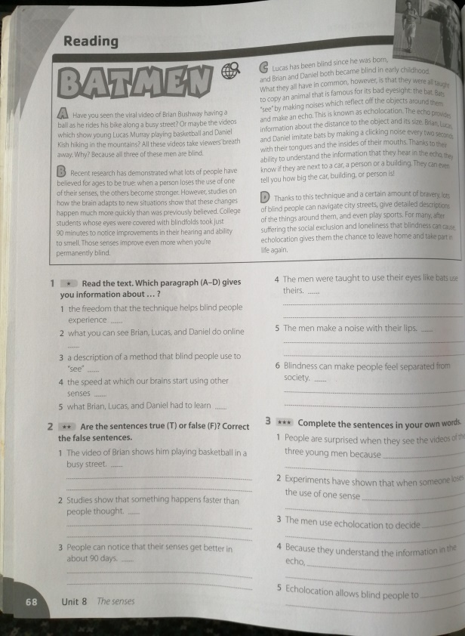
Thursday April 2nd, Friday April 3rd Student’s book pages 146 and 147 Workbook page 70
*for activity 1 from the Student’s book, read the text 4.12
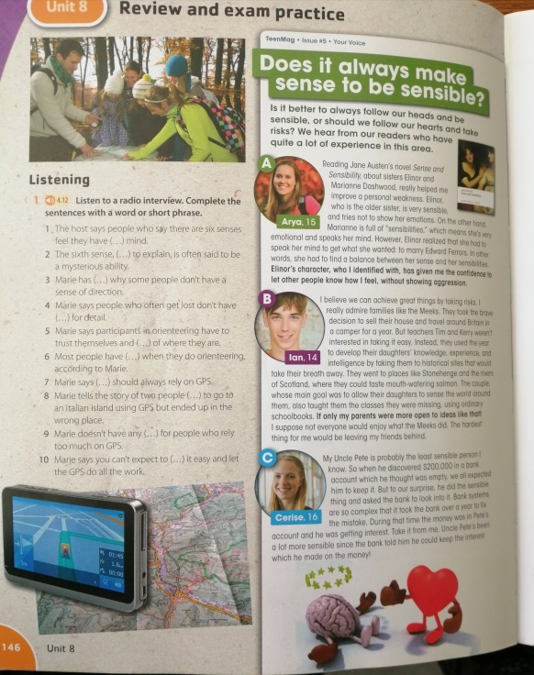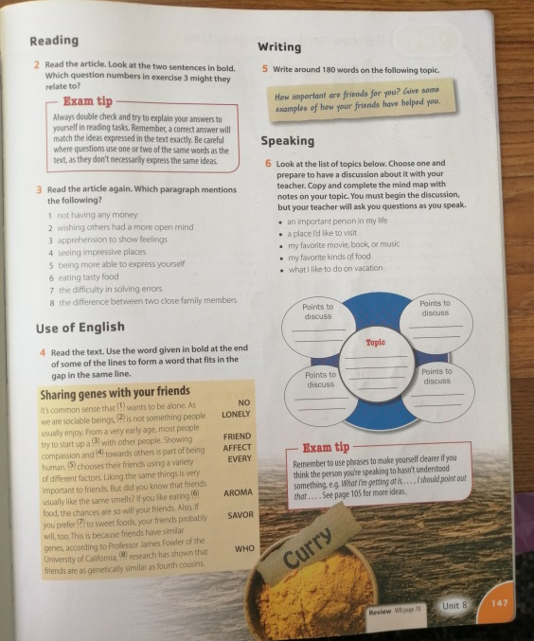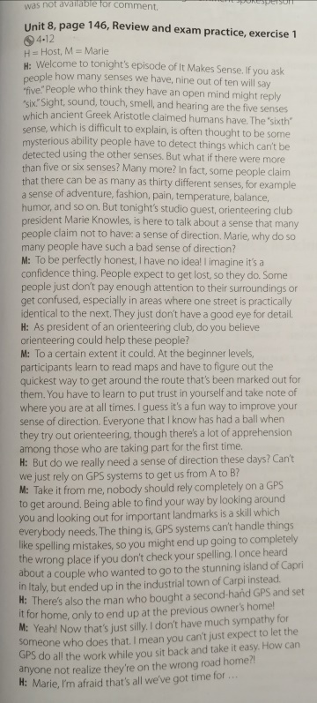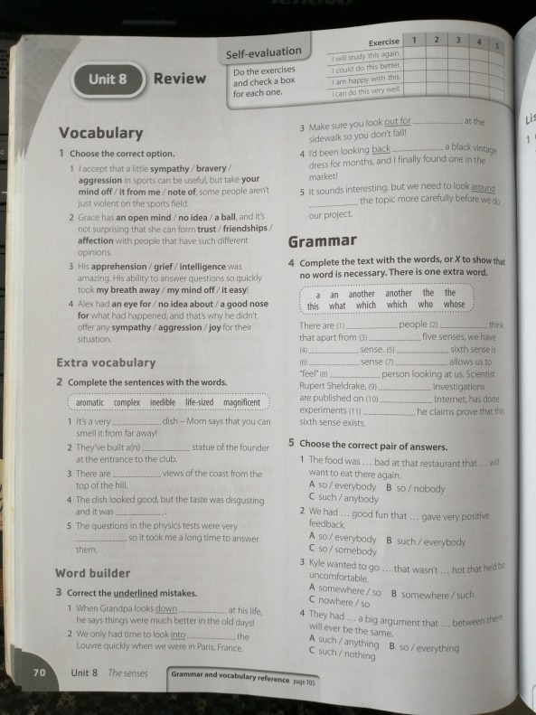

This week’s MyOn book is called “Is time travel possible?” , you have to write the book report on the 2nd section of your notebook.

