[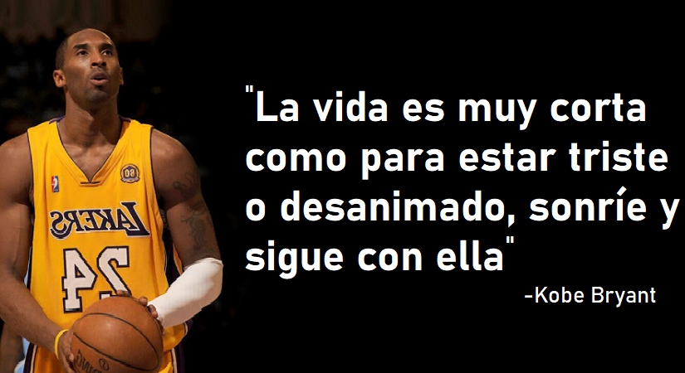](https://www.google.com/url?sa=i&url=https%3A%2F%2Fpositivomundo.com%2Findex.php%2F2020%2F01%2F28%2F10-frases-kobe-bryant-inspiran-mejor%2F&psig=AOvVaw0Hx1mfsUjziHWr_UxSaYiU&ust=1581629986672000&source=images&cd=vfe&ved=0CAIQjRxqFwoTCLDq_v78zOcCFQAAAAAdAAAAABBQ)